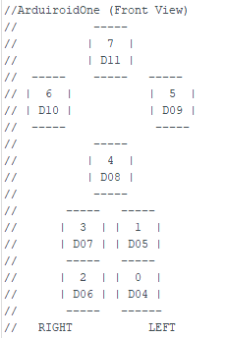

0 = 1197.25 4,789

1= 1657.25 6,629

2- 1985.75 7,943

3 = 1299.50 5,198

4 = 1600.00 left 6400

Right

4 = 1233.75 4935

\*

Zero degree = 1350.50 number 4 5402